Lab 02: Data model and model-driven app
In this lab you will be implementing the data model for the solution and building a model-driven app that will be used by anyone fixing problems or managing the overall effort.
- What you will learn
- Create Tables, Columns, and relationships
- Create model-driven app
- Create a site map
- Create and configure Table forms
- Create and configure Table views
- High-level lab steps
- Exercise 1 – Create publisher and solution
- Exercise 2 – Implement the data model
  - Data Model
    - Building
    - Department
    - Problem Report
- Exercise 3 – Configure forms and views
- Exercise 4 – Compose a basic model-driven app
- Exercise 5 – Input data and refine some views, import some problem reports
- Detailed steps
- Exercise 1: Create publisher and solution
In this exercise, you will create a custom solution publisher and a solution. This custom solution will be used in all the labs for this course to keep all the assets together.

Task 1: Create publisher and solution
- Navigate to the Power Apps maker portal and make sure you are in the correct environment assigned to you.
- Select Solutions and click + New solution.
- Enter Company 311 for Display name.
- Click on the Publisher dropdown and select + Publisher.
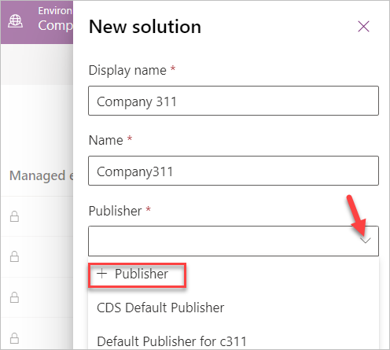
- Enter Lamna Healthcare for Display name, lh for Prefix, and click Save and Close.
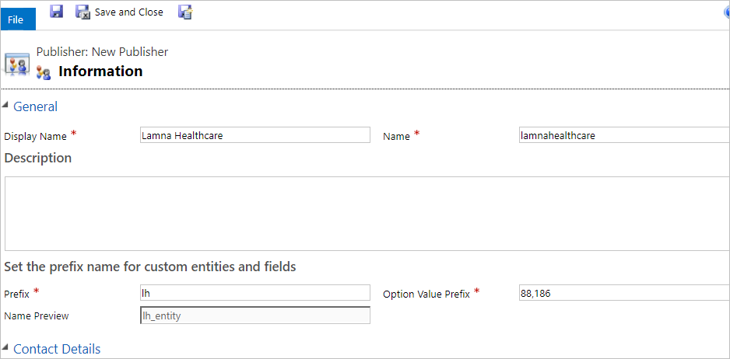
- Click Done on the popup.
- Click on the Publisher dropdown again and select the Lamna Healthcare publisher you created.
- Click Create.
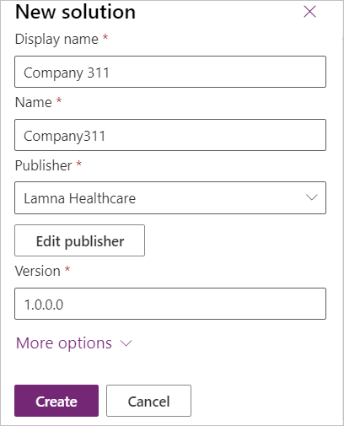
- You should now see the solution you crated in the solution list.
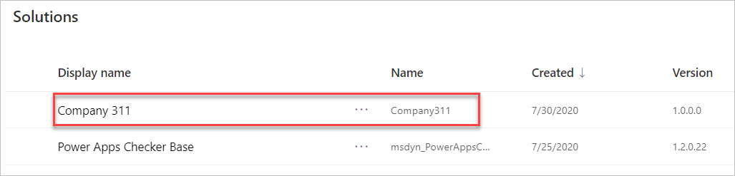
- Exercise 2: Implement data model
In this exercise, you will create Tables, Columns, and the relationships you identified when you designed the data model for the Company 311 app.

Task 1: Create Tables
- In the Power Apps maker portal select Solutions and click to open the Company 311 solution you created in Exercise 1.
- Click + New and select Table.
- Enter Building for Display name and click Done.
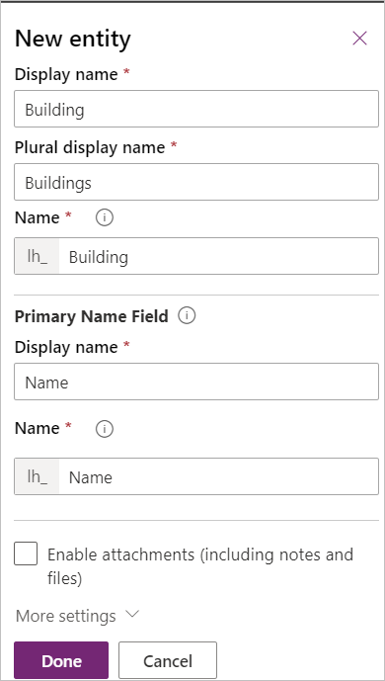
- Go back to the solution by clicking on the solution name.
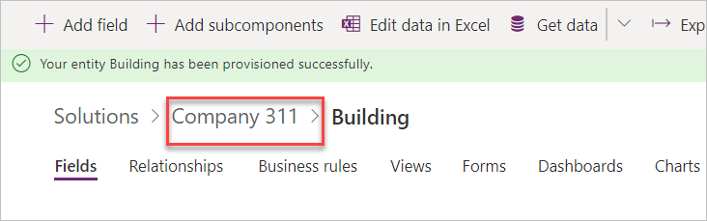
- Click + New and select Table again.
- Enter Department for Display name and click Done.
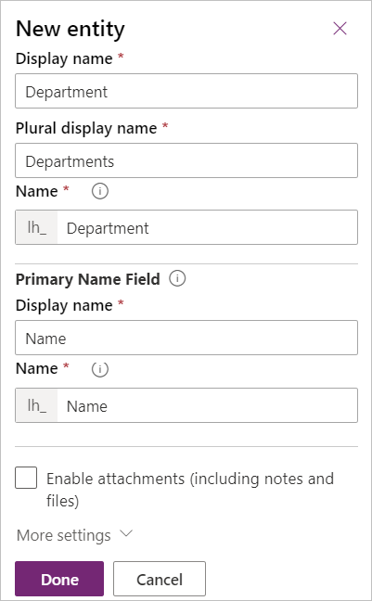
- Go back to the solution by clicking on the solution name.
- Click + New and select Table one more time.
- Enter Problem Report for Display name, change the Primary Column Display name to Title, and click More settings.
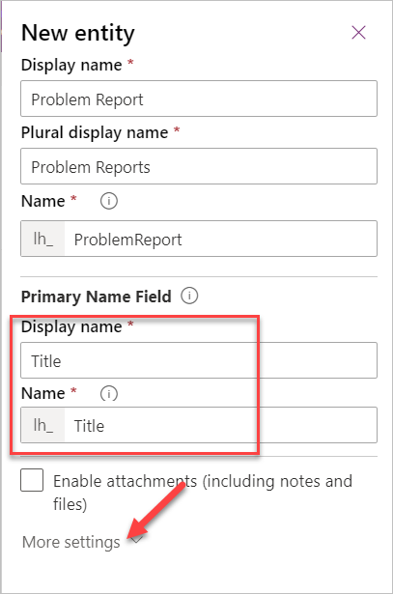
- Click to expand the Collaboration section.
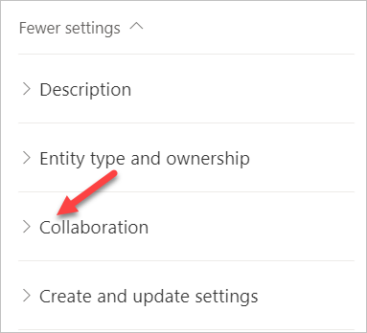
- Check the Enable queues checkbox and click Done. Enabling queues allows Problem Report Rows to be associated with one or more queues to help facilitate routing to the different departments.
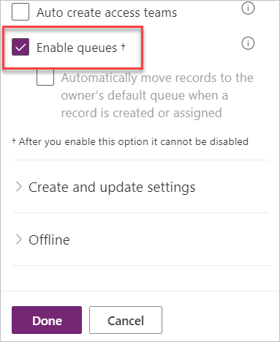
- Click Okay on the Confirm changes popup.
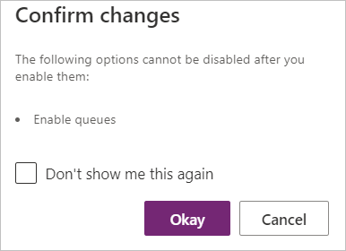

Task 2: Add Columns
In this task, you will add Columns to the Problem Report Table.
- Navigate to the Power Apps maker portal page and make sure you are in the correct environment.
- Select Solutions and click to open the Company 311 solution you created in exercise 1.
- Locate and click to open the Problem Report Table.
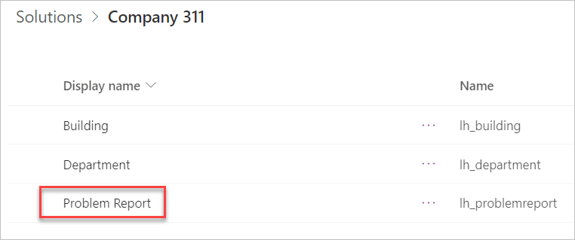
- Select the Columns tab and click + Add Column.
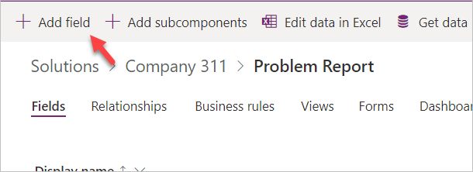
- Enter Location for Display name, select Text for Data type, and click Advanced options.
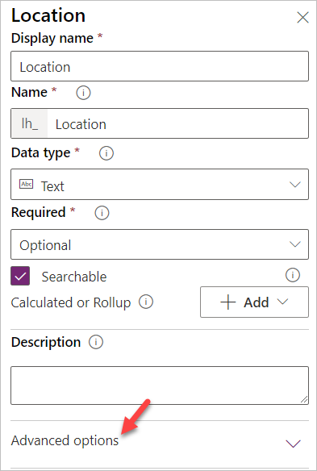
- Change Max length to 150 and click Done.
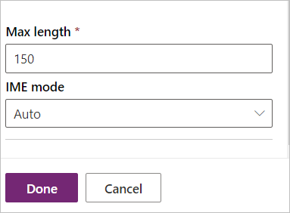
- Click + Add Column again.
- Enter Details for Display name, select Multiline text for Data type, make the Column Required, and click Done.
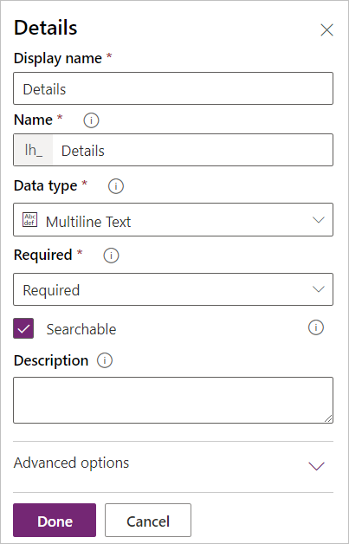
- Click + Add Column again.
- Enter Photo for Display name, select Image for Data type, and click Done.
- Click + Add Column.
- Enter Resolution for Display name, select Multiline text for Data type, and click Done.
- Click + Add Column.
- Enter Resolved On for Display name, select Date and time for Data type, and click Done.
- Click Filter and select Custom
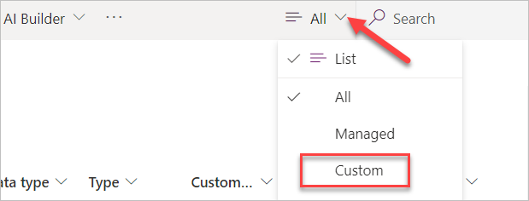
- You should now see the 5 new Columns you created. Click Save Table.
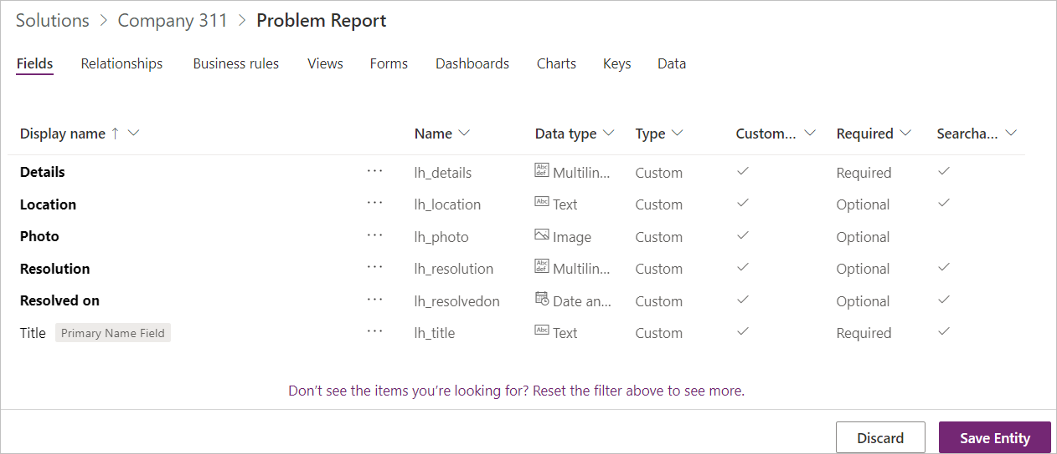
- Go back to the solution by clicking on the solution name.
- Click Publish all customizations and wait for the publishing to complete.
- Do not navigate away from this page.

Task 3: Edit status reason Choice
In this task, you will edit the status reason Column of the problem report Table.
- Make sure you are in the Company 311 solution.
- Click to open the Problem Report Table.
- Click on the … More commands button and select Switch to classic.
[!NOTE]
You are switching to classic because the modern solution explorer does not support editing status reason yet but will in the future.
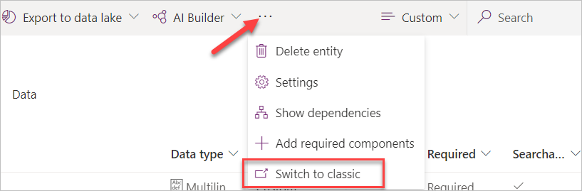
- Select Columns and double click to open the Status Reason Column.
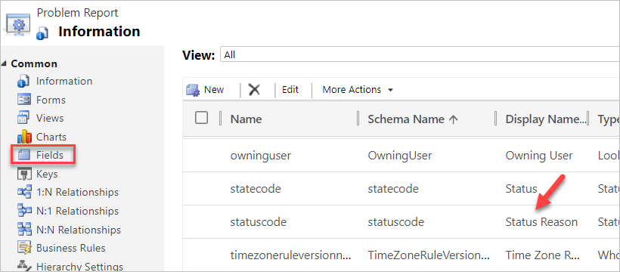
- Make sure Active is selected for Status and double click to open the Active option.
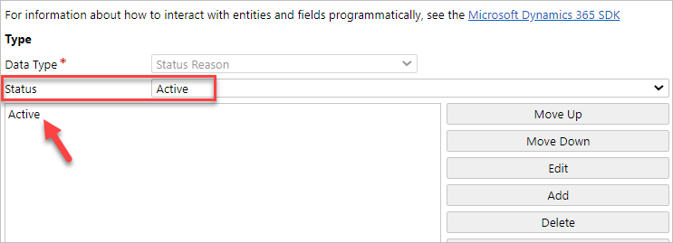
- Change the Label value to New and click OK.
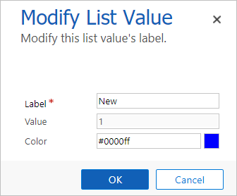
- Click Add.
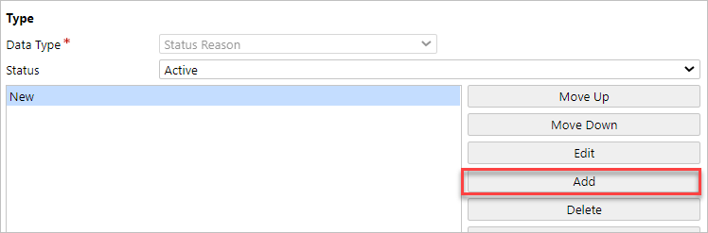
- Enter Assigned for Label and click OK.
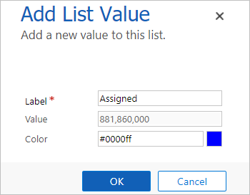
- Click Add again.
- Enter In Progress for Label and click OK.
- Click Add again.
- Enter Completed for Label and click OK.
- Click Add one more time.
- Enter Won’t Fix for Label and click OK.
- You should now have 5 options. Select New for Default Value and click Save and Close.
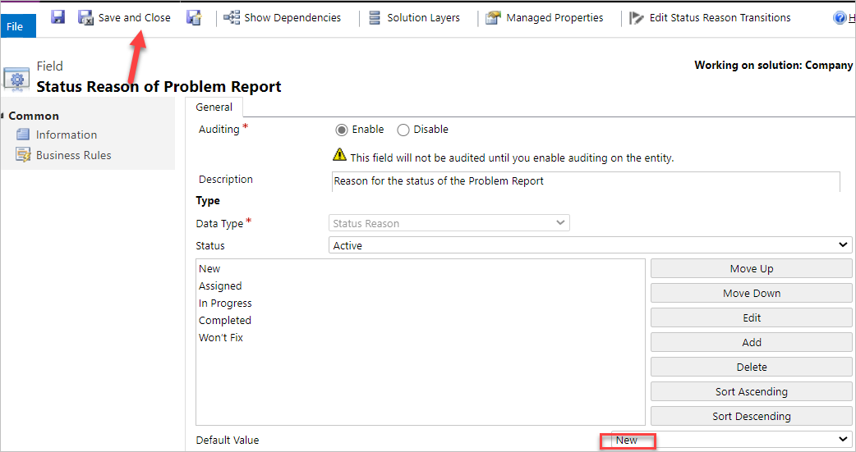
- Click Publish and wait for the publishing to complete.
- Click Save and Close to close the classic editor.
- You should now be back on the Power Apps Maker portal.
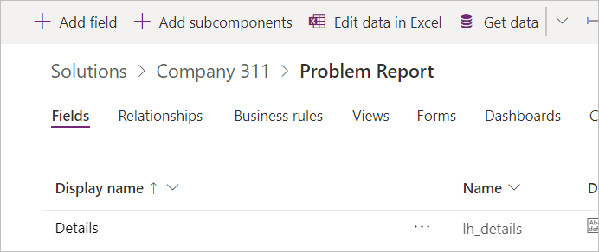
- Do not navigate away from this page.

Task 4: Relationships
In this task, you will create many to one relationships between the problem report Table and the building and department Tables.
- Make sure you are in the Problem Report Table.
- Select the Relationships tab and click + Add relationship.
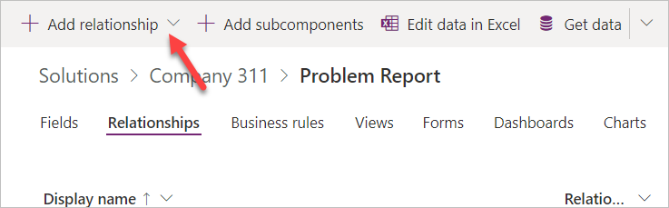
- Select Many-to-one.
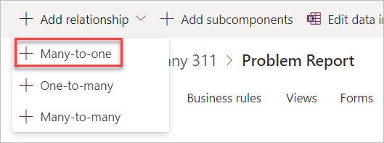
- Select Building for Related (One) Table and click Done.
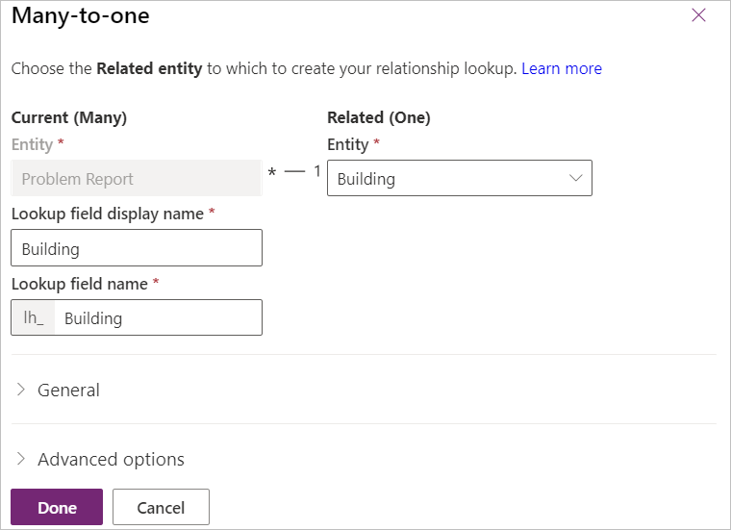
- Click + Add relationship again.
- Select Many-to-one.
- Select Department for Related (One) Table and click Done.
- Click Save Table.
- Go back to the solution by clicking on the solution name.
- Click Publish all customizations and wait for the publishing to complete.
- Exercise 3: Configure form and views
In this exercise, you will configure form and views for the problem report Table.

Task 1: Configure form
- Navigate to the Power Apps maker portal and make sure you are in the correct environment.
- Select Solutions and click to open the Company 311 solution.
- Locate and click to open the Problem Report Table.
- Select the Forms tab and click to open the Main form.
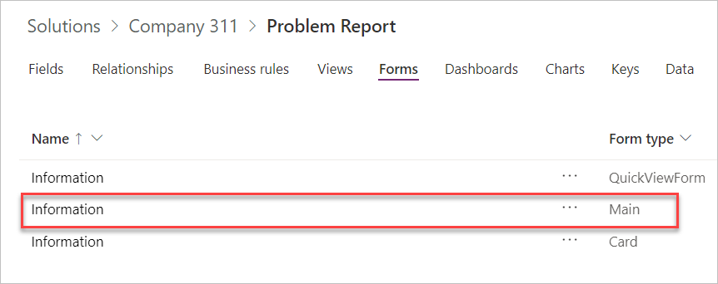
- Select the form section.
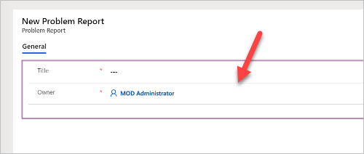
- Go to the Properties pane, change the Section label to Problem details, and enter section_problem_report for Name.
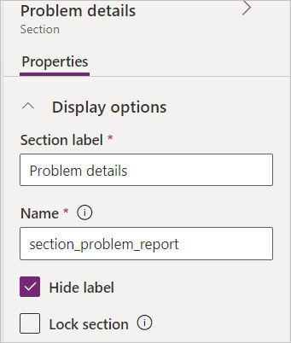
- While you still have the section selected, go to the Columns pane, and click on the Building Column. The Building Column will be added to the form.
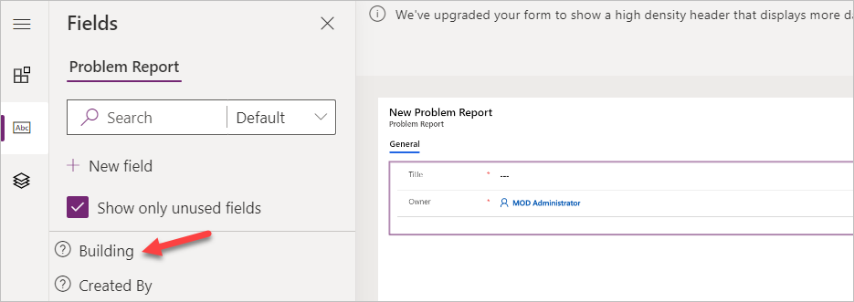
- Add the Details, and Photo Columns to the form.
- Your form should now look like the image below. Select the Details Column.
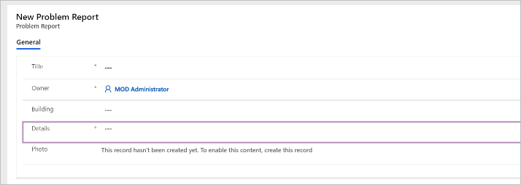
- Go to the Properties pane and click to expand the Formatting section.
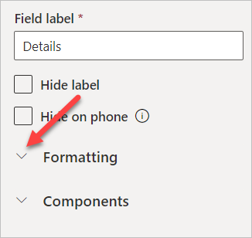
- Change the Column height to 4.
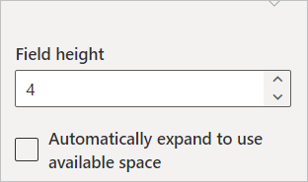
- Select the Components from the toolbar.
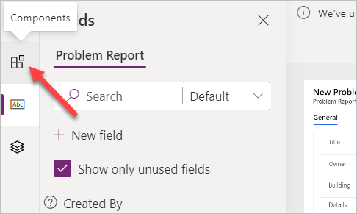
- Select 1-Column section.
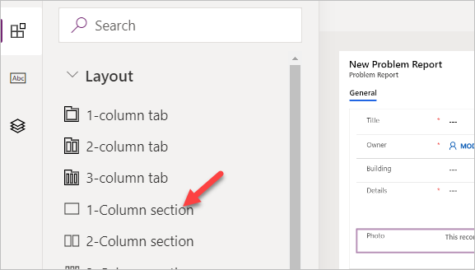
- A new section should be added to the form. Select the new section.
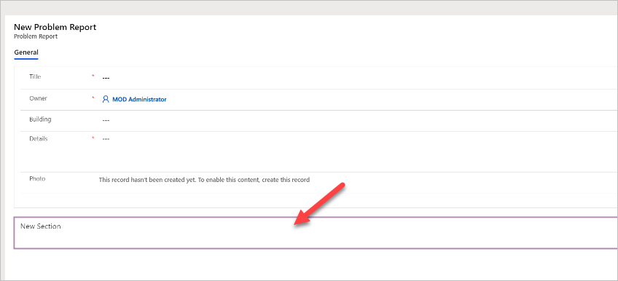
- Go to the Properties pane, change the Section label to Resolution details, and change the Name to section_resolution_details.
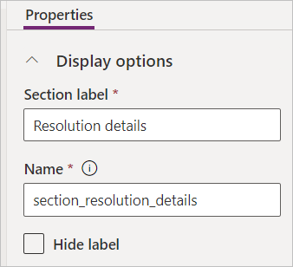
- Select Columns from the toolbar.
- Add Department, Status Reason, Resolved on, and Resolution Columns to the Resolution details section.
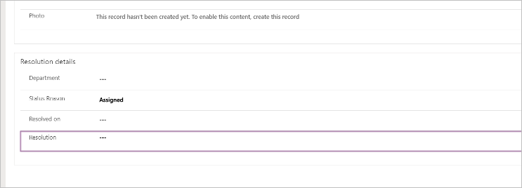
- Select the Resolution Column.
- Go to the Properties pane and click to expand the Formatting section.
- Change the Column height to 4.
- You form should now look like the image below. Click Save.
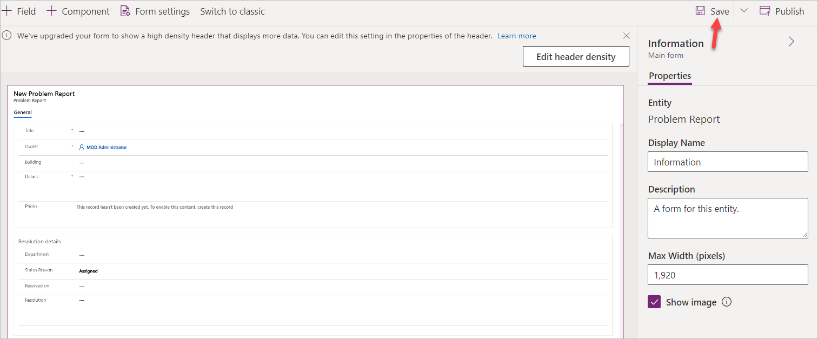
- Click Publish and wait for the publishing to complete.
- Click on the <- Back button.
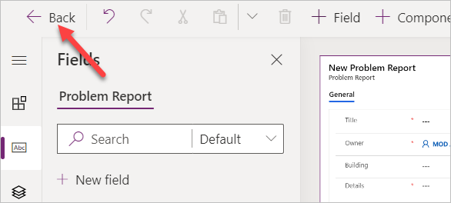
- You should now be back to the Table.
- Do not navigate away from this page.

Task 2: Edit view
- Select the Views tab and click to open the Active Problem Reports view.
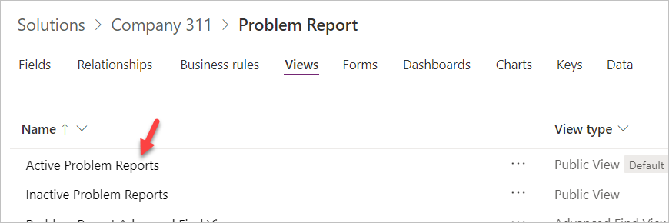
- Click + Add column and select Building.
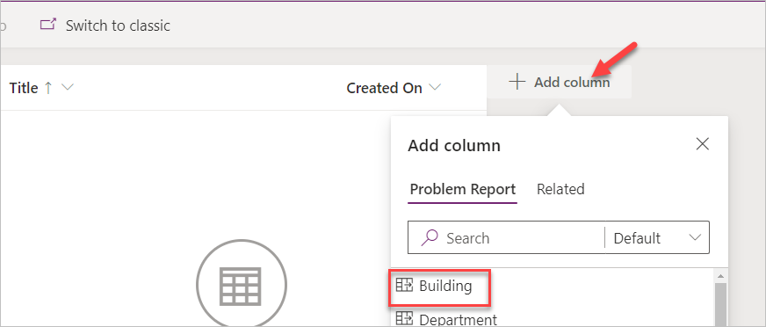
- Add Location, Status Reason, and Owner columns to the view. You will have to change the filter to All when adding status reason and owner columns.
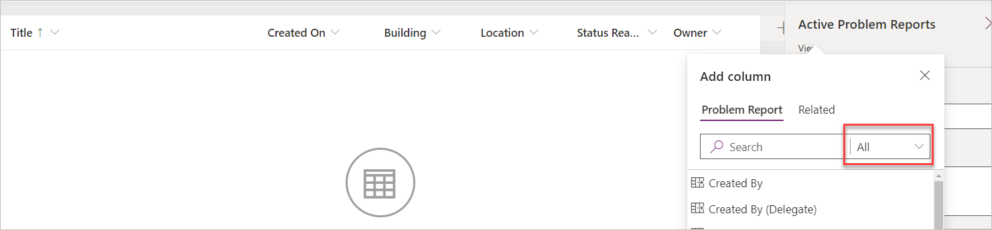
- Go to the view properties pane and click Edit filters.
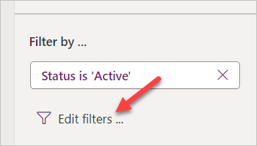
- Set the first filter to Status Reason Equals New.
- Click on the Column where you New selected.
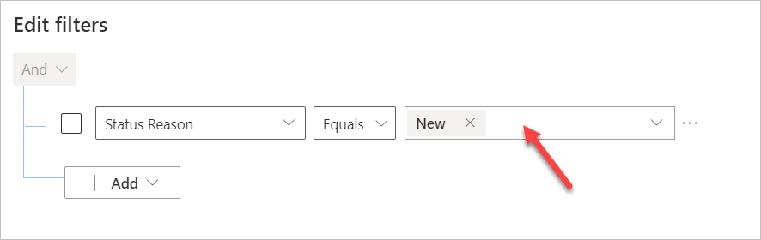
- Select Assigned.
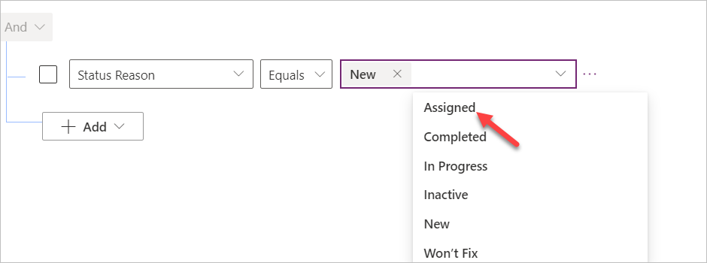
- Click on the filed again and select In progress.
- The filter should now look like the image below. Click OK.
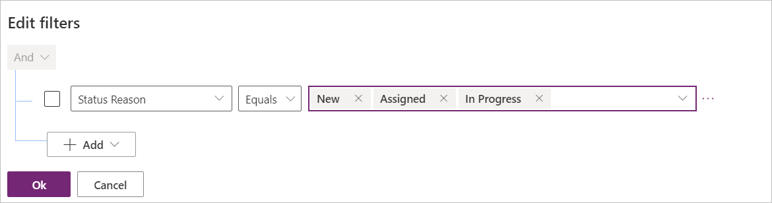
- Click Save.
- Do not navigate away from this page.

Task 3: Create view from existing
In this task, you will create a new view from the Active Problem Reports view.
- Click Edit filters.
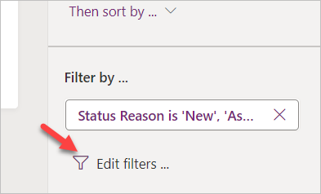
- Remove In Progress from the filter.
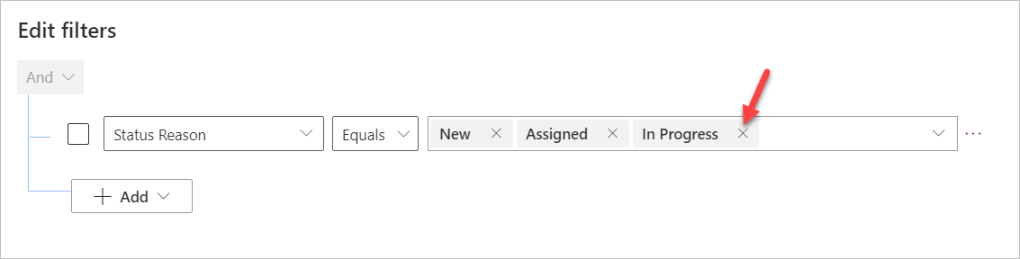
- Remove Assigned and New values form the filter.
- Select Completed.
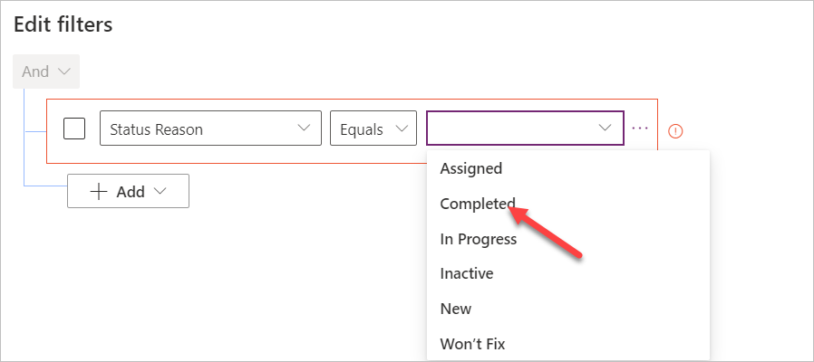
- Add Won’t Fix and Inactive values to filter.
- The filter should now look like the image below. Click OK.
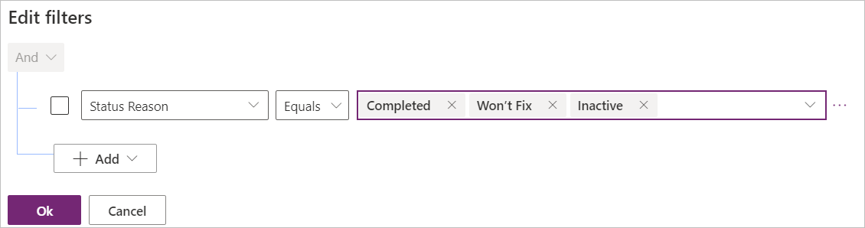
- Click on the chevron button next to the save button and select Save As.
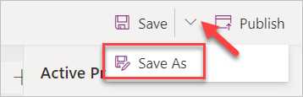
- Enter Resolved Problems for Name and click Save.
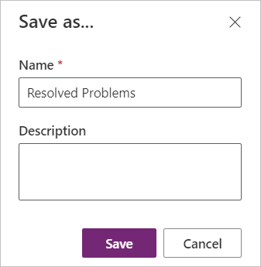
- Click on the <-Back Button.
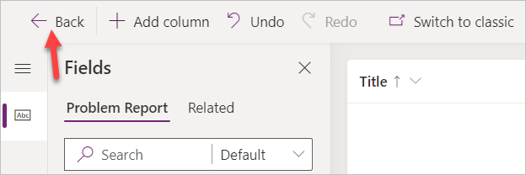
- Go to the solution by clicking on the solution name.
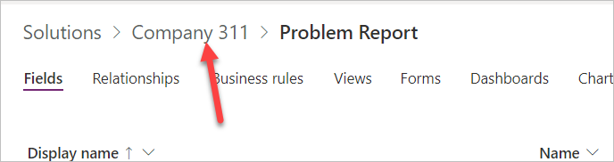
- Click Publish all customizations and wait for the publishing to complete.
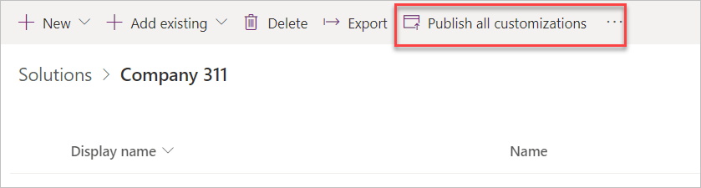
- Exercise 4: Compose model-driven application
In this exercise, you will create model-driven application.

Task 1: Create new model-driven application
- Navigate to the Power Apps maker portal and make sure you are in the correct environment.
- Select Solutions and click to open the Company 311 solution.
- Click + New | App | Model-driven app.
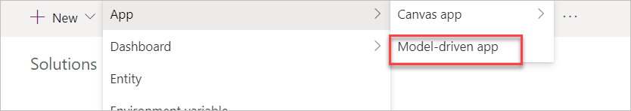
- Enter Company 311 Admin for name and click Done.
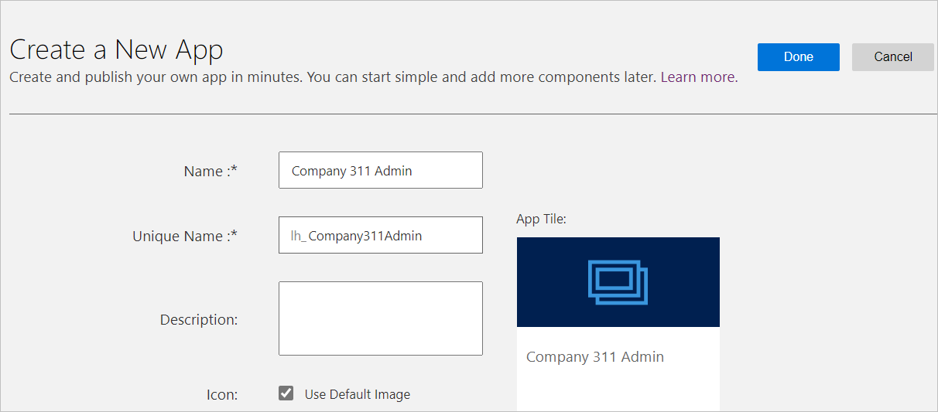
- Click Edit Site Map.
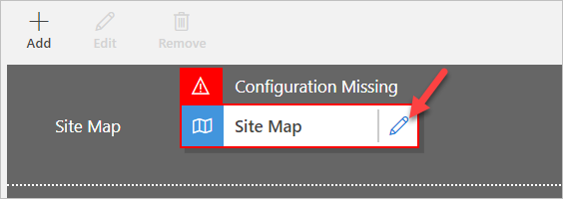
- Select the New Area.
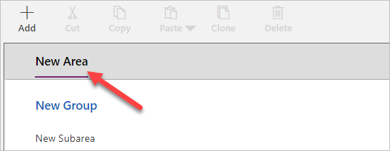
- Go to the Properties pane, enter Manage Problems for Title, and enter area_manage_problems for ID.
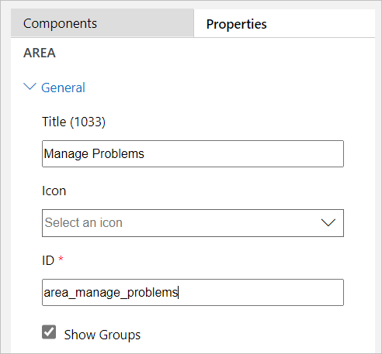
- Select the New Group.
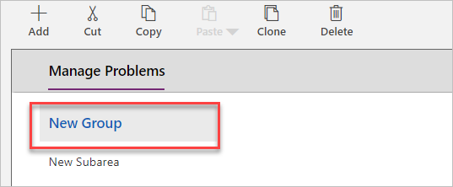
- Go to the Properties, enter Problems for Title, and enter group_problems for ID.
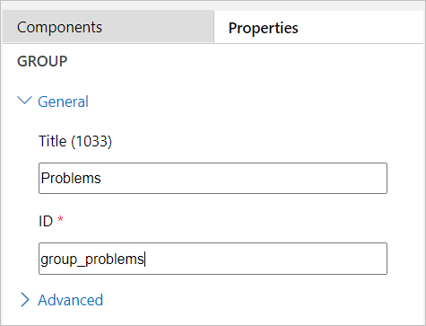
- Select the New Subarea.
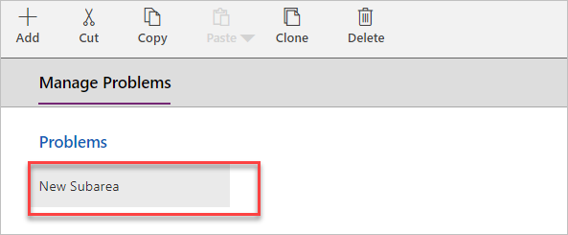
- Go to the Properties pane, select Table for Type, and select Problem Report for Table.
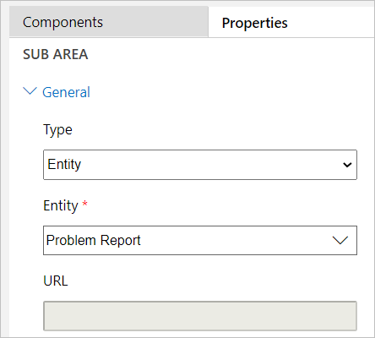
- Click + Add.
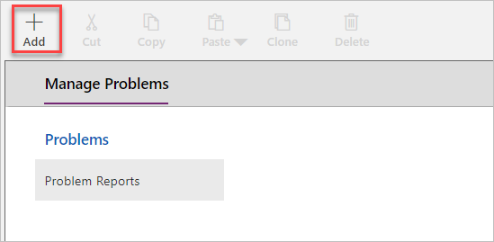
- Select Area.
- Select the New Area you just added.
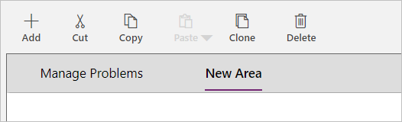
- Go to the Properties pane, enter Settings for Title, and enter area_settings for ID.
- Select the Settings area and click + Add.
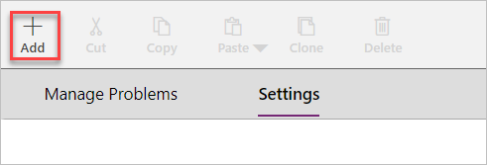
- Select Group.
- Select the New Group you just added.
- Go to the Properties pane, enter Taxonomy for Title, and enter group_taxonomy for ID.
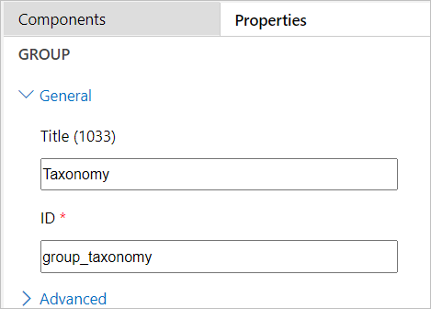
- Select the Taxonomy group you just added and select the Components pane.
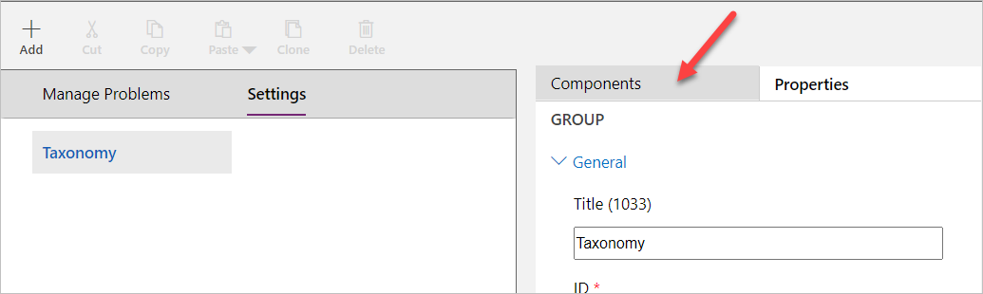
- Drag Subarea and drop it under the Taxonomy group.
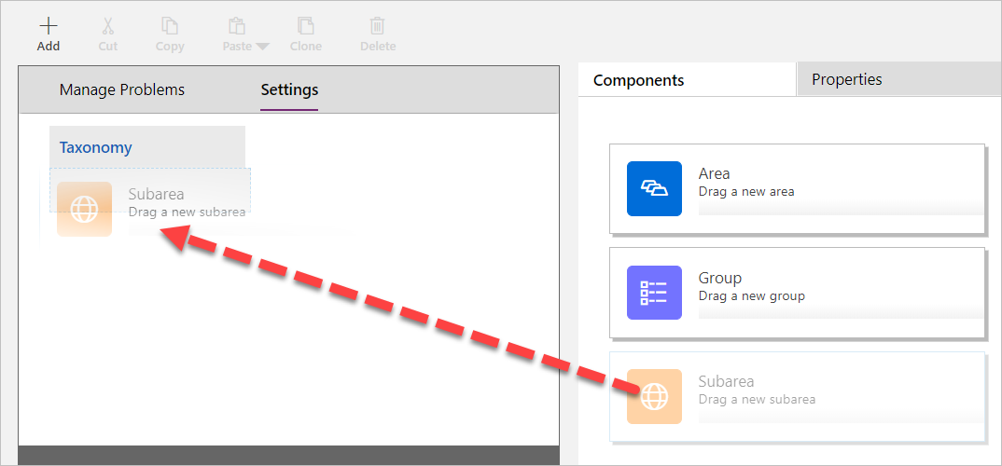
- Select the New Subarea.
- Go to the Properties pane, select Table for Type, and select Building for Table.
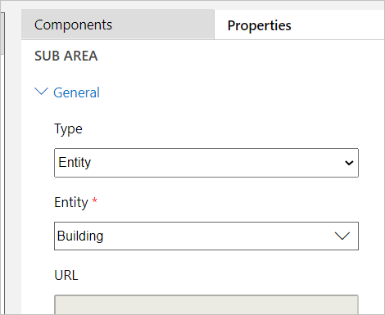
- Add another Subarea component to the Taxonomy group.
- Select the New Subarea.
- Go to the Properties pane, select Table for Type, and select Department for Table.
- The sitemap should now look like the image below. Click Save to save the sitemap.
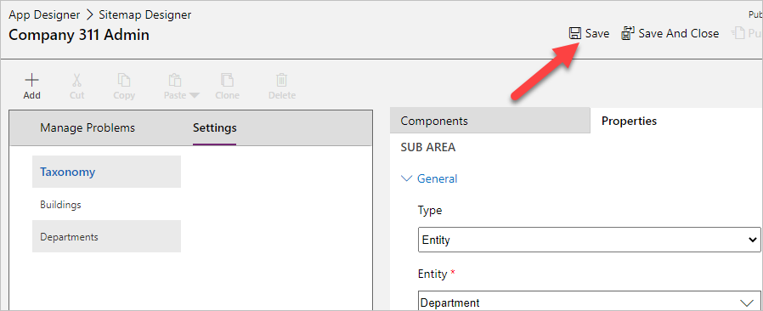
- Click Publish to publish the sitemap and wait for the publishing to complete.
- Go back to the App Designer.
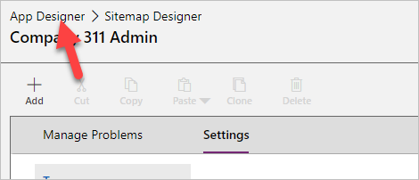
- The application should now have three Tables. Click Save to save the application.
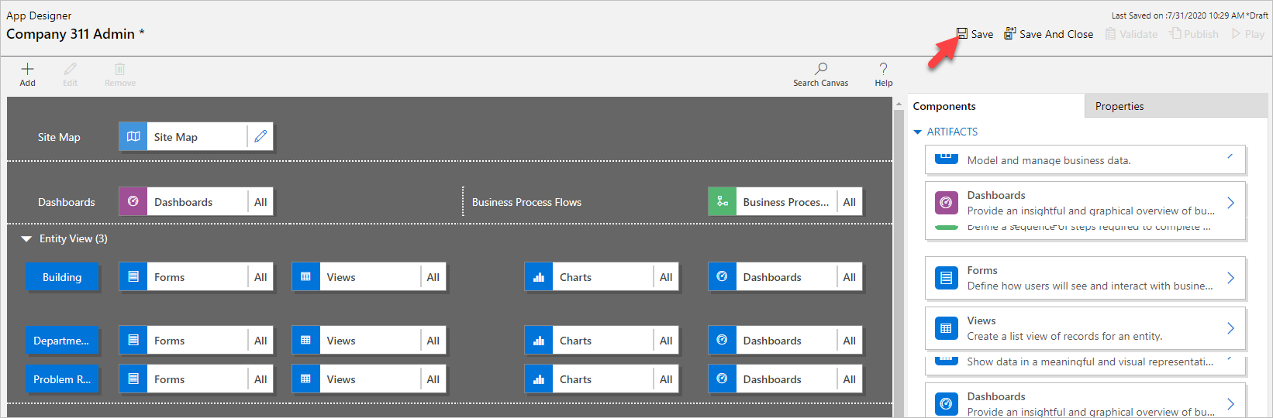
- Click Publish to publish the application and wait for the publishing to complete.
- Close the app designer browser tab or window.
- Click Done.
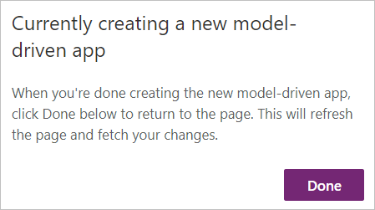
- Exercise 5: Input data
In this exercise, you will input data.

Task 1: Input data
- Navigate to the Power Apps maker portal and make sure you are in the correct environment.
- Select Apps and click to open the Company 311 Admin application you created.
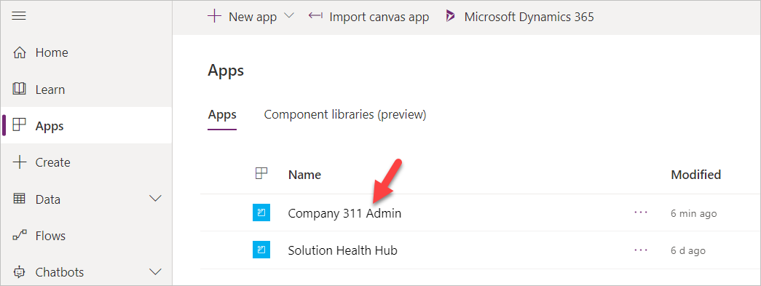
- Click Change area.
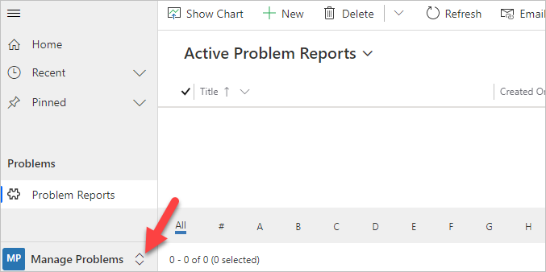
- Select Settings area.
- Select Departments and click + New.
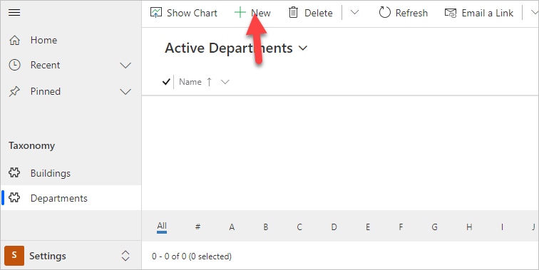
- Enter Facility Maintenance for Name and click Save.
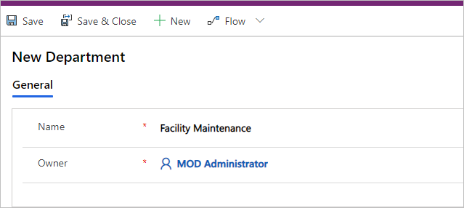
- Click + New again.
- Enter Human Resources for Name and click Save.
- Click + New one more time.
- Enter Marketing for Name and click Save.
- Select Departments.
- You should now have three department Rows. Select Buildings.
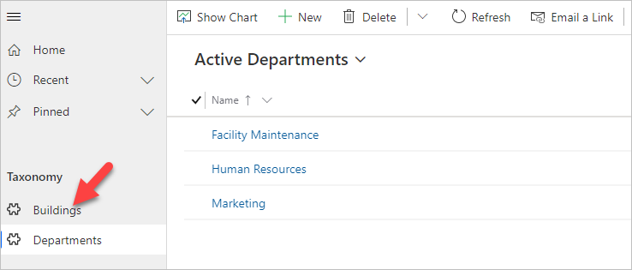
- Click + New.
- Enter San Francisco Main Campus for Name and click Save & Close.
- Click + New again.
- Enter London Paddington for Name and click Save & Close.
- You should now have two building Rows. Click Change area.
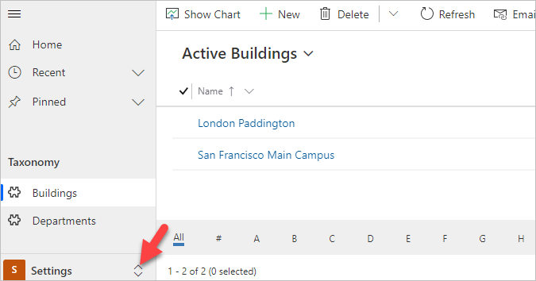
- Select Manage Problems.
- Click + New.
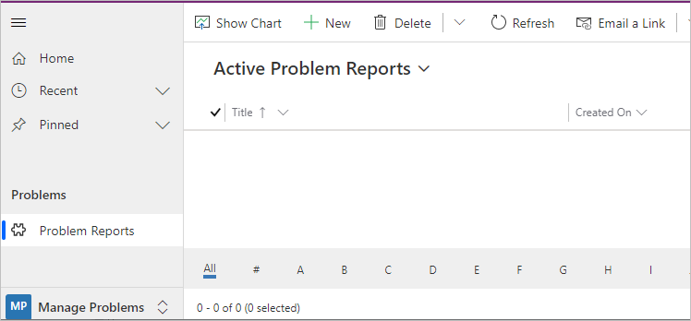
- Enter Broken door for Title, select San Francisco Main Campus for Building, enter The main entrance door will not open all the way for Details, and click Save
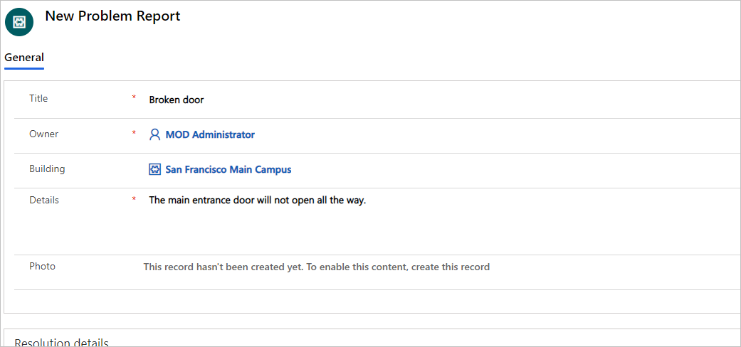
- Click on the Photo Column.
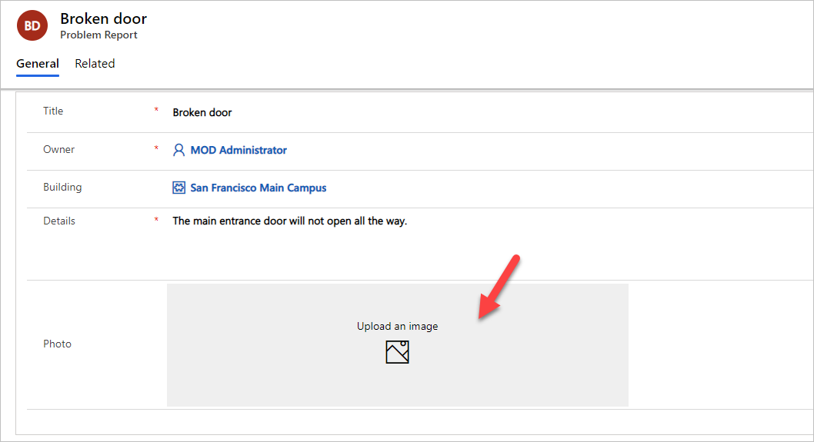
- Select an image from your device.
- The image should now show on the form.
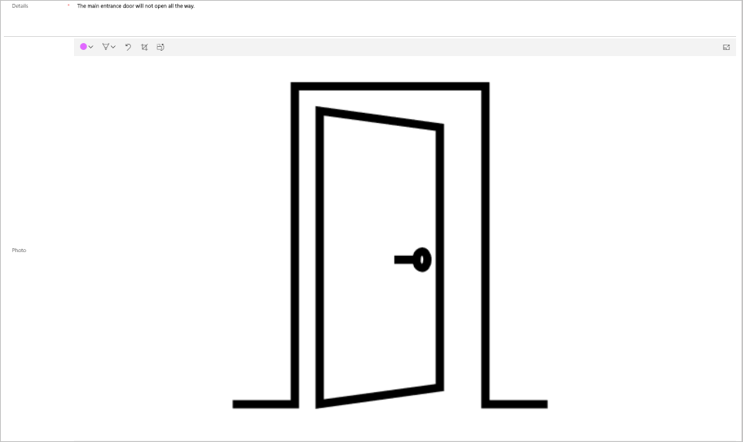
- You may add more Rows.
- Exercise 6: Import data
In this exercise, you will import sample data into your environment. Rows are imported by a Power Automate flow that you will first import using a solution.

Task 1: Import solution
- Navigate to the Power Apps maker portal and make sure you are in the correct environment.
- Select Solutions and click Import.
- Click Choose File.
- Select the DataImport.zip solution file located in the lab resources folder and click Open.
- Click Next.
- Click Next again.
- Click Import and wait for the solution import to complete.
- Click Publish all customizations and wait for the publishing to complete.
- Click Close the to close the solution import wizard.

Task 2: Review and run flow
- Navigate to the Power Apps maker portal and make sure you are in the correct environment.
- Select Solutions and click to open the Data Import solution you imported.
- Click to open the Import Data flow.
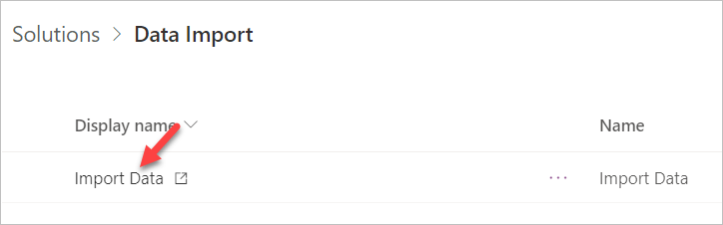
- Click Edit.
- Click Continue.
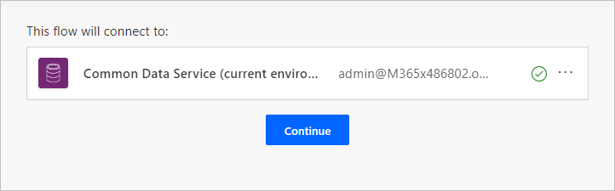
- Click to expand the Input Data step.
- Review the Json text in the value Column. This is the data that will be imported into your environment
- Expand the Each Department for each control
- Expand and review the Upsert Department step.
- Expand and review the rest of the steps.
- Click Save to save the flow.
- Click on the button and go back to the flow details page.
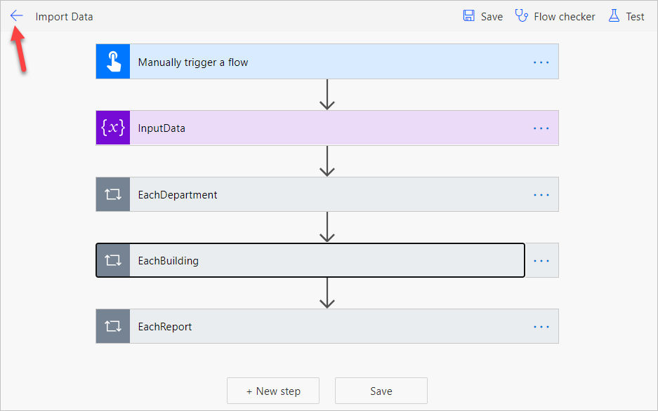
- Click Run.
- Click Run flow.
- Click Done.
- Wait for the flow run to complete. Click on the Refresh button to check if the flow run completed successfully.
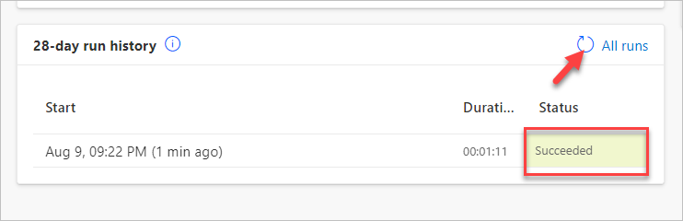
- Close the flow editor browser window or tab.
- Click Done on the popup

Task 3: Review imported data
- Navigate to the Power Apps maker portal and make sure you are in the correct environment.
- Select Apps and click to open the Company 311 Admin application.
- Select Problem Reports and change the view to My Reports. You should see at least three new Rows.
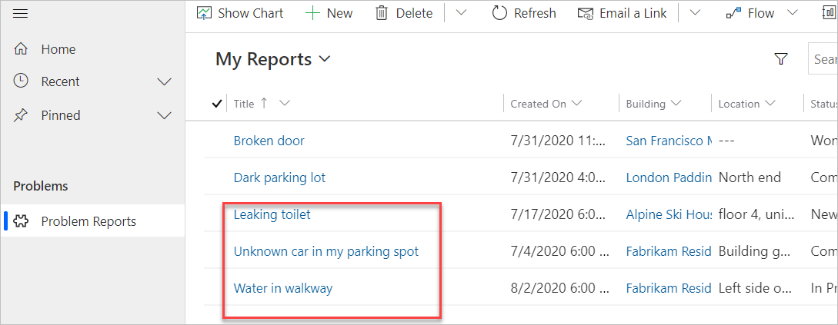
- Click to open one of the Problem Report Rows.
- Click on the Building lookup and make sure building Rows were imported.
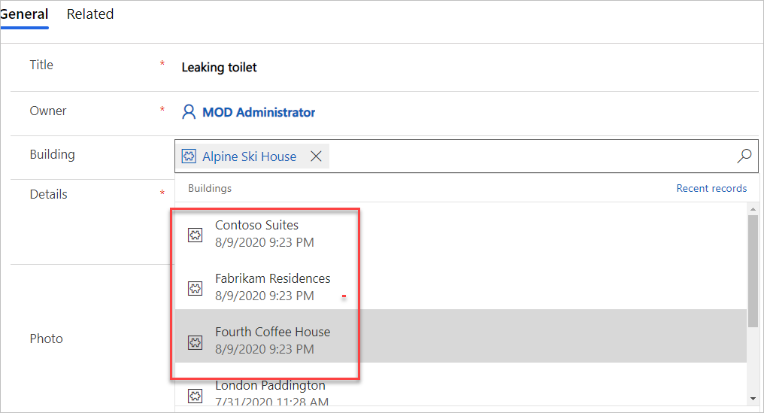
- Scroll down and click on the Department lookup.
- Make sure the department Rows got imported.

